Clemson University

Mosaicking
Assignment 4, ECE 877
Ujwal C Naik
Assignment Number 4

Report for the 4th assignment for Computer Vision – ECE 877.

Introduction:
Image mosaicking or image stitching is the process of combining multiple images that have overlapping fields of view to obtain an image of higher resolution. In this assignment we take a number of pictures that describe parts of the object of interest, detect pairs of features that convey maximum amount of information and then using these correspondences we warp the pictures with respect to a central image(the picture with most overlapping regions) and stitch them together to get a picture that describes the entire scene.

Method:
In this assignment we have implemented a greatly simplified version of the image stitching algorithm explained in Richard Szeliski’s book: Computer Vision: Algorithms and Applications. For the purpose of simplicity we have hard-coded the feature correspondences that would other-wise be found using a feature detector/descriptor such as SIFT/SURF/DAISY. To avoid parallax errors we use pictures taken from the same location with slight change in rotation.
The method followed for implementation of image mosaicking is as follows:
- Load the images: In this step we load the images into an array and then the images are transferred over to a larger canvas and set at the center of the canvas.
- Load the correspondences: The correspondences tell us the location of the feature in different images. We load the correspondences into a vector of points. These vectors will be used while calculating the homographies of the various images.
- Create Homography Mapping: In this step we create homography mapping between the central image and the other images. If the image is directly connected to the central image then the homography is calculated with respect to the central image and the homography matrix is obtained. If the image is not connected to the central image then we calculate homography with respect to an image connected to the central image and then multiply the resultant homography matrix with the central image homography matrix to get a matrix that describes the homography of the image with respect to the central image.
- Warping: Using the homography matrices calculated the images are warped with respect to the central image.
- Feathering: The overlap of images is handled using feathering to describe which image gets how much weightage in the final out-put. This is done using the chamfer distance. The distance from the warped image is labeled d2 and the distance from the central image is labeled d1. The output is weighted as :
- After the images are feathered the are stitched to the bigger canvas hence giving us the required output.
Algorithm:
The algorithm for image-stitching is as follows:
- Load the images and place it in an array. Set the images to the center of larger sized canvas.
- Load the correspondences into vectors of points.
- Obtain the homography matrices with respect to the central image.
- Warp the images with respect to the central image using the calculated homography matrices.
- Feathering and stitching: When the images are overlapping perform feathering to decide the weight of the different images on the overlap region. Then stich the various parts of the result to get final outcome.

RESULTS

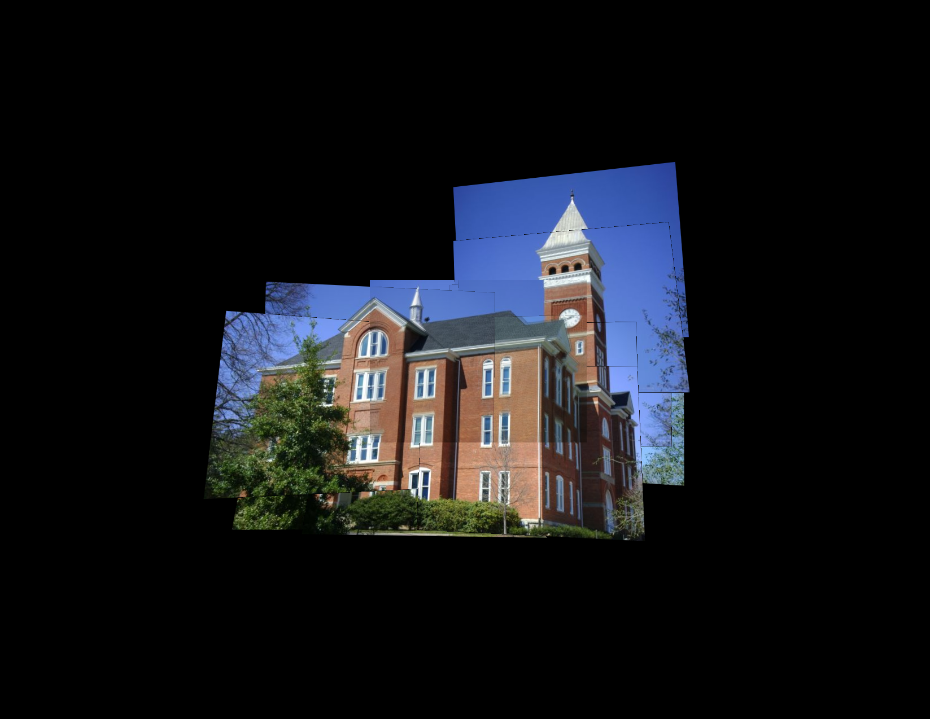
Result obtained from stitching the different images.

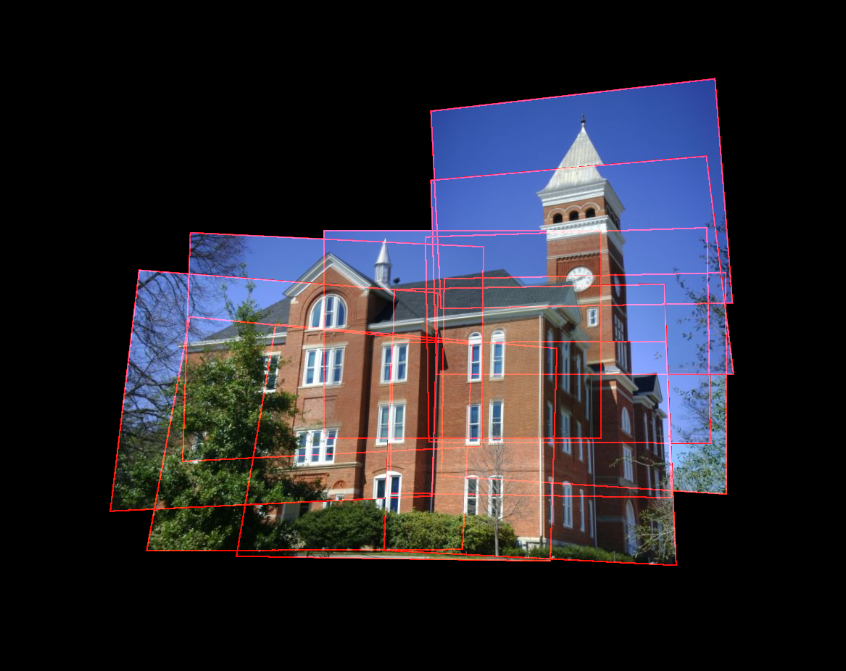
Result showing the outline of all the warped images.
Conclusion
The image stitching algorithm provides a reasonably good representation of the scene. The results produced by this algorithm produce recognizable high resolution images of the desired scene from various smaller images with overlapping field of view.
However, the output also has some noticeable flaws that can’t be removed easily. Ghosting is observed at many locations in the image causing quite a few edges to seem to have a shadow. Image warping also leads to some loss of information.
Also, the feature detector used must be very robust because mismatch of feature correspondences will lead to poorly stitched image.

